2011 Annual Conference on Christian Philosophy
FRANCISCAN UNIVERSITY OF STEUBENVILLE

THE EARLY PHENOMENOLOGY
MUNICH and GÖTTINGEN

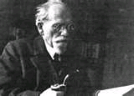
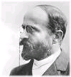

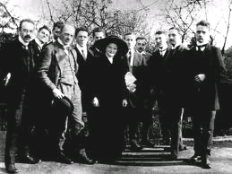

April 29th and 30th 2011

Sponsored by the

M.A. Program in Philosophy
Franciscan University of Steubenville

Friday April 29th

MORNING SESSIONS
Continental Breakfast and Registration
Totino Room: St. Joseph Center
7:15 A.M.

SESSION ONE
Seminar Room: St. Joseph Center
8:00 A.M. – 9:45 A.M.
Sponsored by
North American Society for Early Phenomenology

Chair: Guillaume Fréchette
Université du Québec à Montréal

Jason Bell
Mount Allison University
Scheler's Secret Seminars, Göttingen 1911-1914

Kimberly Baltzer Jaray
Independent Scholar
Notes From the Battlefield Pt. 2: Further
Explorations of Reinach’s ‘Phenomenology of Foreboding’

Jeff Mitscherling
University of Guelph
Ontology and Cognition of the Filmic Work of Art:
A Programmatic Statement of How
Ingarden Might Proceed Today

SESSION TWO
Seminar Room: St. Joseph Center
9:55 A.M. – 11:05 A.M.
Sponsored by
The Dietrich von Hildebrand Legacy Project

Chair: John Crosby
Franciscan University of Steubenville

Mathew Lu
University of St. Thomas, Minnesota
Universalism, Particularism, and Subjectivity:
Dietrich von Hildebrand's Concept of "Eigenleben"
and Modern Moral Philosophy

Michael Wenisch
Independent Scholar
Toward the Articulation of a Systematic
von Hildebrandian Political Philosophy

KEYNOTE ADDRESS

Sponsored by
North American Society for Early Phenomenology

Seminar Room: St. Joseph Center
11:15 A.M. – 12:15 P.M.

Chair: Kimberly Baltzer-Jaray
Independent Scholar

Antonio Calcagno
King's University College
The University of Western Ontario

The Problem of the Relation between the State
and the Community in Edith Stein’s Political Theory

Lunch for Conference Participants
Totino Room: St. Joseph Center
12:15 P.M.

AFTERNOON SESSIONS

SESSION THREE
Seminar Room: St. Joseph Center
1:00 P.M. – 2:45 P.M.

Sponsored by
North American Society for Early Phenomenology

Chair: Kimberly Baltzer-Jaray
Independent Scholar

Robin Rollinger
University of Salzburg
The Phenomenology of Reflective Consciousness:
From Brentano to Pfänder

Rodney Parker
The University of Western Ontario
Empathy Theories from Lotze to Husserl

Guillaume Fréchette
Université du Québec à Montréal
The Unity of Consciousness in Early Phenomenology

SESSION FOUR
Seminar Room: St. Joseph Center
2:55 P.M. – 4:05 P.M.
Sponsored by
The Dietrich von Hildebrand Legacy Project

Chair: Michael Wenisch
Independent Scholar

John Crosby
Franciscan University of Steubenville
Dietrich von Hildebrand on Deliberate Wrongdoing

Fritz Wenisch
University of Rhode Island
“Sorting Out Feelings”
How I Became a Hildebrandian

SESSION FIVE
Seminar Room: St. Joseph Center
4:15 P.M. – 5:25 P.M.

Chair: Mark Roberts
Franciscan University of Steubenville

Nicholas Rescher
University of Pittsburgh
Hedwig Conrad-Martius
and the Self-Transcendence of Phenomenology

Mark Roberts
Franciscan University of Steubenville
Why I Became a Phenomenologist

Dinner for Conference Participants
Totino Room: St. Joseph’s Center
Wine and Refreshments 6:15 P.M.
Dinner 6:30 P.M. – 7:30 P.M.

KEYNOTE ADDRESS

Sponsored by
The Dietrich von Hildebrand Legacy Project

Seminar Room: St. Joseph Center
7:30 P.M.
Chair: John Crosby
Franciscan University of Steubenville

Alice von Hildebrand
Professor Emerita: Hunter College
Widow of Dietrich von Hildebrand

The Memoirs of Dietrich von Hildebrand:
Shedding New Light
on the Early History of Phenomenology

Reception Immediately Following
Totino Room: St. Joseph Center

Saturday April 30th

MORNING SESSIONS
Continental Breakfast and Registration
Totino Room: St. Joseph Center
7:15 A. M.

SESSION SIX
Concurrent Sessions
8:00 A.M. – 9:10 A.M.

Session Six (A)
Room A: St. Joseph Center

Chair: Joseph Friona
Franciscan University of Steubenville

Philip Harold
Robert Morris University
The Idea of Value-Ethics in Early Phenomenology

Michael C. Pezzulo
Franciscan University of Steubenville
Reconsidering Scheler on Truth in the Experience
of Value and on the Nature of Obligation:
A Dialogue with Scheler’s Critics

Session Six (B)
Room B: St. Joseph Center

Chair: Joseph Spencer
Franciscan University of Steubenville

Oliver Heydorn
University of Arkansas – Fort Smith
The Epistemology of Phenomenological Realism
as a Higher Synthesis

Ron Muller
Cardinal Newman Liberal Arts Project
God, Phenomenology, and the Ontology of Essence:
The Case for Moderate Platonism

SESSION SEVEN
Concurrent Sessions
9:20 A.M. – 11:05 A.M.

Session Seven (A)
Room A: St. Joseph Center
Sponsored by
The Dietrich von Hildebrand Legacy Project

Chair: Michael Healy
Franciscan University of Steubenville
Ewa Agnieszka Pichola
Cardinal Stefan Wyszynski University
Warsaw, Poland
A Treatise on Truth
The Unity of Sermons of Blessed Fr. Jerzy Popieluszko
and the Philosophy of Dietrich von Hildebrand

Richard Sherlock
Utah State University
From Phenomenology to Metaphysics:
Scheler, Hildebrand, and Lonergan

Lewis McCrary
Georgetown University
Von Hildebrand as Response to Kantian
Accounts of Respect and Love

Session Seven (B)
Room B: St. Joseph Center

Chair: Jonathan Sanford
Franciscan University of Steubenville

Uldis Vēgners
University of Latvia
Theodore Celms’ Critique of Husserl’s
Transcendental Phenomenology

J. Edward Hackett
Southern Illinois University, Carbondale
Ruminations on Section 49, Ideas 1

Eduardo Gonzalez Di Pierro
Universidad Michoacana de San Nicolas de Hidalgo
Morelia, Michoacan, Mexico
Edith Stein as a Philosophical Key to Understanding
the Relation Between “Realist Phenomenology”
and Husserl’s “Transcendental Turn”
SESSION EIGHT
Concurrent Sessions
11:15 A.M. – 12:25 P.M.

Session Eight (A)
Room A: St. Joseph Center

Chair: Ron Muller
Cardinal Newman Liberal Arts Project

Zachary Davis
St. John’s University
The Promise of Solidarity: Reinach and Scheler

Eric Mohr
Duquesne University
Does Aristotle’s Ethics Represent Pharisaism?
A Survey of Scheler’s Critique

Session Eight (B)
Room B: St. Joseph Center

Chair: Joseph Spencer
Franciscan University of Stuebenville

Micah Tillman
Catholic University of America
Do Numerals Mean Anything?
Husserl’s Theory of Signs in “Mechanical” Calculation

Carlos Bovell
Institute for Christian Studies, Toronto
The Mathematician is not really the Pure Theoretician
but only the Ingenious Technician

Lunch for Conference Participants
Seminar Room: St. Joseph Center
12:25 P.M.

AFTERNOON SESSIONS

SESSION NINE
Concurrent Sessions
1:10 P.M. – 2:55 P.M.

Session Nine (A)
Room A: St. Joseph Center

Chair: William Doub
Franciscan University of Steubenville

James Barasel
Franciscan University of Steubenville
Towards an Analysis and Critique of “Vitalistic Christianity”
in Max Scheler and Rudolf Eucken

David Klassen
Corpus Christi College
Scheler and Wojtyla on Cognition of Values

Joel Potter
SUNY, Buffalo
Arguments from the Priority of Feeling in Contemporary
Emotion Theory and Max Scheler’s Phenomenology

Session Nine (B)
Room B: St. Joseph Center

Chair: Robert Mentyka
Franciscan University of Steubenville
Catherine Nolan
SUNY Buffalo
Husserl, Scheler and Merleau-Ponty on Habit

Jonathan Kim-Reuter
Georgian Court University
Stein, Husserl, and the Givenness of Others

Michael F. Andrews
Dean, Matteo Ricci College
Seattle University
Edith Stein and Max Scheler:
Empathy, Reciprocity,
and the Constitution of the Acting Person

Session Nine (C)
Totino Room: St. Joseph Center

Chair: Darek Ikhwan
Franciscan University of Steubenville

John K. O’Connor
Colorado State University, Pueblo
Logical Grammar
and the Dissolution of Philosophical Problems

Mentos Tang
The Chinese University of Hong Kong
Husserl’s Concepts of Evidence and Intuition:
In What Way do They Differ from Ordinary
Concepts of Proof and Argument?
From the Perspective of Early Husserl

Christopher S. Morrissey
Redeemer Pacific College
Thomas Aquinas and Adolf Reinach on States of Affairs

SESSION TEN
Concurrent Sessions
3:05 P.M.-4:15 P.M.

Session Ten (A)
Room A: St. Joseph Center

Chair: William Doub
Franciscan University of Steubenville

Trevor Bieber
The University of Western Ontario
Max Scheler and the Nature of Self-Love
A Criticism of Scheler’s Argument
Against Reductive Theories of Love

Holly Mohr
Duquesne University
Franciscan University
Moving From the “They” to a “We”:
How Max Scheler’s Nature of Sympathy
Paves the Way for a “Dream of a Common Language”

Session Ten (B)
Room B: St. Joseph Center

Chair: Robert Mentyka
Franciscan University of Steubenville

David Dillard-Wright
University of South Carolina Aiken
Pfänder's Philosophy of Willing and Motivation

Diego I. Rosales Meana
Center for Advanced Social Research, Mexico
The Experience of Motivation.
Some Comments on the Relations Between
Intentionality and Will in Edith Stein and Edmund Husserl

Session Ten (C)
Totino Room: St. Joseph Center

Chair: Darek Ikhwan
Franciscan University of Steubenville

Timothy Martell
Murray State University
Phenomenology and Phenomenalism in Husserl’s
Thing and Space

John R. White
Franciscan University of Steubenville
Eric Voegelin’s Critique of Husserlian Intentionality

KEYNOTE ADDRESS

Rooms A & B: St. Joseph Center
4:25 P.M. – 5:25 P.M.

Chair: Mark Roberts
Franciscan University of Steubenville

Dallas Willard
School of Philosophy
University of Southern California, Los Angeles

Realism Sustained:
Interpreting the Alleged Progression of Husserl into Idealism

Banquet
Seminar Room, St. Joseph Center
Wine and Refreshments 6:15 P.M.
Dinner 6:45

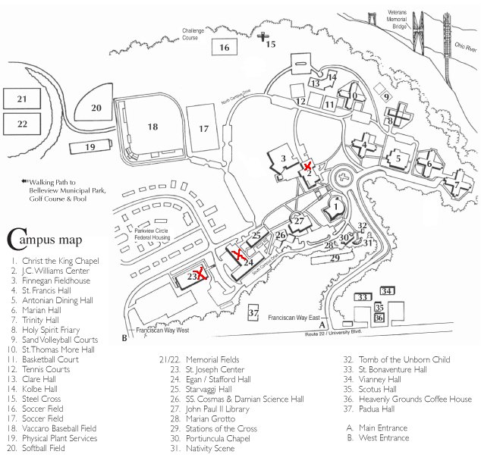

NOTES

