Husserl-Archiv
of the University of Cologne
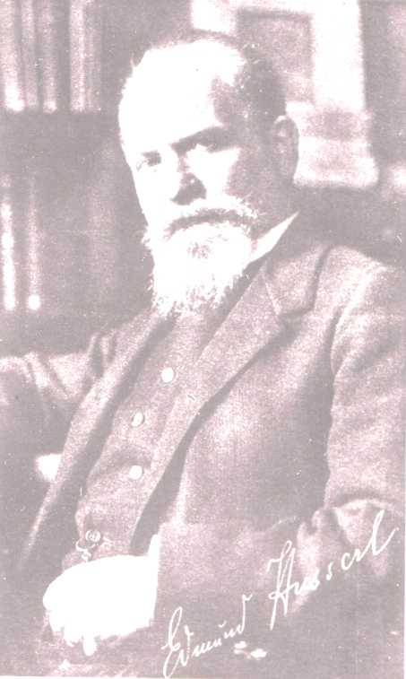
Cologne-Leuven Summer School in Phenomenology:

Essentials of Husserl’s Phenomenology
27-31. July 2009

This Summer School in English language should give an insight in the central themes of husserlian phenomenology: intentionality, evidence, categorial intuition, the eidetic method, transcendental reduction, the levels of constitution, time-constitution, genetic analysis of prepredicative judgement, intersubjectivity, life-world and Husserl‘s critique of science.
These themes will be presented in lectures, each day in the time 10-13.00 together with a discussion. In the afternoon in the time 15-17.00 there will be a textual analysis that should go into some details and in this way help to enhance the understanding. The lecturers are: Prof. Dr. U. Melle (Leuven), Prof. Dr. D. Lohmar (Köln), Dr. A. Altobrando (Köln), Dr. J. Brudzinska (Köln / Warschau), Luis Niel (Köln) et. al.

We are planning for a level that should help to inform intensively on the essential topics of Husserlian phenomenology on a medium level but we are also open for discussions of methodical questions on the level of doctoral students and postdocs. This course will be also handled as a "Hauptseminar" for the students of Cologne university. To get a qualified certificate for this Hauptseminar a written paper on a topic to be determined is expected.
This international Summer School is open for students from all countries.

IMPORTANT: Written registration is required before June 10, 2009 because of limited capacities! Registration is to be done with the secretary of the Cologne Husserl-Archive:
Monika.Heidenreich@uni-koeln.de

Time: Monday-Friday 27.-31. July 2009
Each day 10.00-13.00 and 15.00-17.00
Room: University of Cologne, Main Building, Room 4.016

Contact: The secretary of the Husserl-Archive (Tel. 0221-470-2367, e-mail: Monika.Heidenreich@uni-koeln.de)

